**Installation of ubuntu 18.04 LTS**

**Short information about Ubuntu 18.04: [Official Website Link] (**[**https://www.ubuntu.com/desktop**](https://www.ubuntu.com/desktop)**).**

-ubuntu is one of the most famous Linux OS distribution amongst various Linux distros which are **open source**

-It provides both command Line(CLI) and Graphical User interface(GUI)

**### Linux based Operating System-Ubuntu (version: ubuntu 18.04 LTS )**

- **Version**: ubuntu 18.04 LTS ( **Desktop versions**)

- **Prerequisites:**

- ubuntu 18.04 LTS OS **.iso file,** **rufus software**

- Download ubuntu 18.04 LTS OS .iso file from this [source] (<https://www.ubuntu.com/download/desktop>).

-Download Rufus software to create bootable pen drive from this [source] (<https://rufus.akeo.ie/downloads/>).

**- Installation Steps**

- download both ubuntu .iso file and rufus software

**Steps:**

1. **Check for Windows genuine(License copy)**

-Right click on This PC and goto properties.

-Note down your Windows product ID

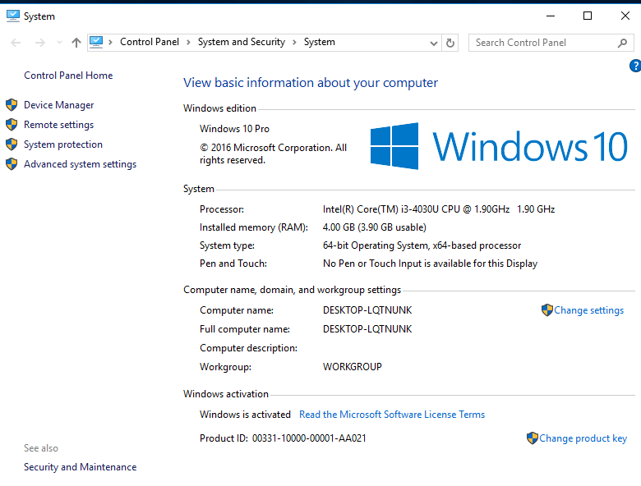

1. **Check for partitioning Scheme:**

-**to check partitioning scheme of your laptop open command prompt(admin) and type commands**

1.diskpart

2.list disk

3.if * under GPT then your partitioning scheme is GPT. And if not your partitioning scheme MBR

(in MBR you can create only primary partitions)

4.Note down your partitioning scheme

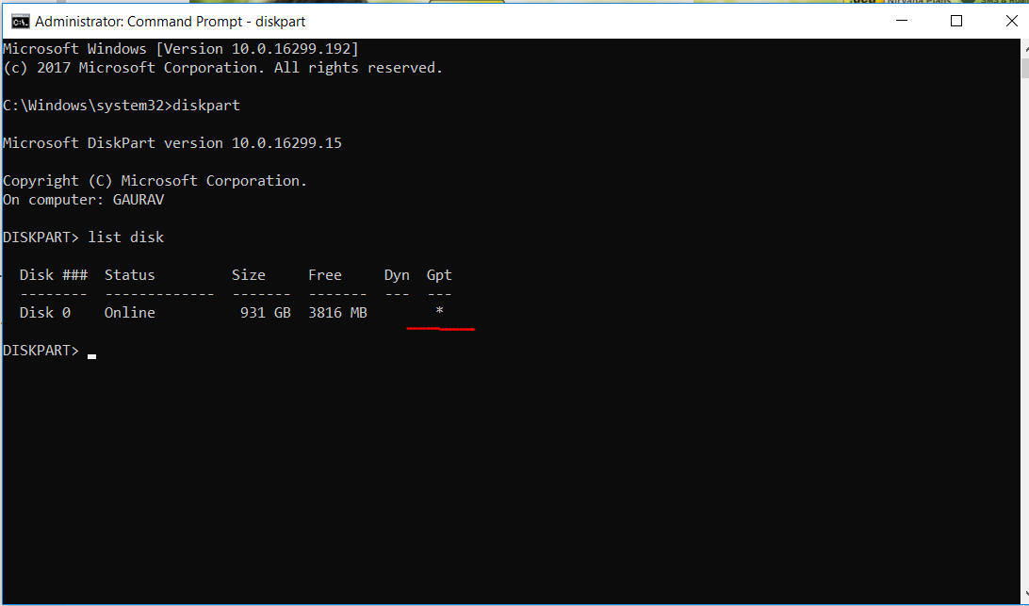

(* under GPT ,hence GPT partitioning scheme)

1. **Checking for BIOS mode**

- open command prompt(admin)

-type cmd msinfo32

-check BIOS mode UEFI or legacy

Note it down

1. **Making Pen drive Bootable using rufus:**

-run rufus on windows, start it, then select iso file of ubuntu

-after selecting iso file then select create bootable disk using iso file

-then select partition scheme target file system as: both GPT and legacy (**in below image only for UEFI mode is select, change it after selecting iso file)**

-start the process.

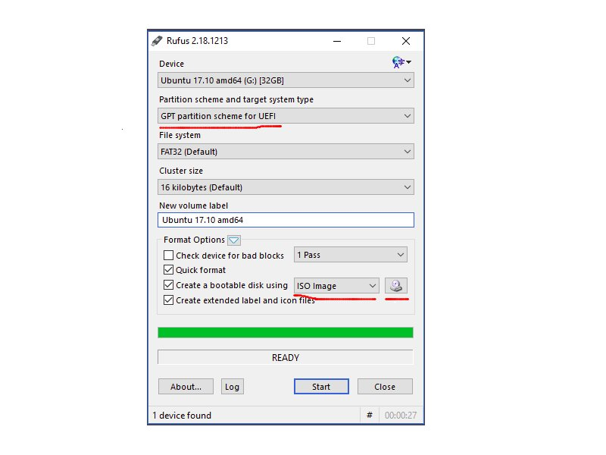

**More about Bootable Pen drive(USB):**

**-**making pen drive bootable means your PC can detect OS present in your Pen drive and boot from that pen drive

-you can also use Disk instead of pen drive

1. **Making disk partition to install Ubuntu**

-**to create disk partition search computer management in windows search bar and then goto disk management**

-**only for GPT**

on any disk partition (strongly recommended other than C:) right click and shrink volume ,then give space for ubuntu partition (**give 50 GB;** black coloured unallocated space volume will be created in which we are going to install OS(ubuntu).

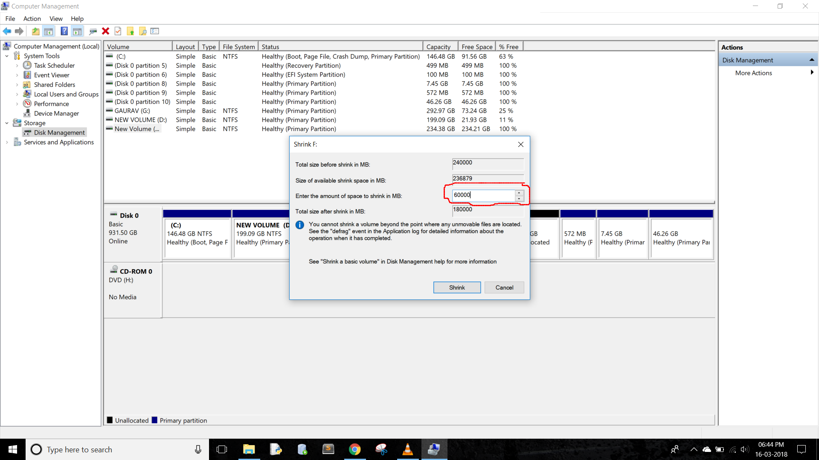

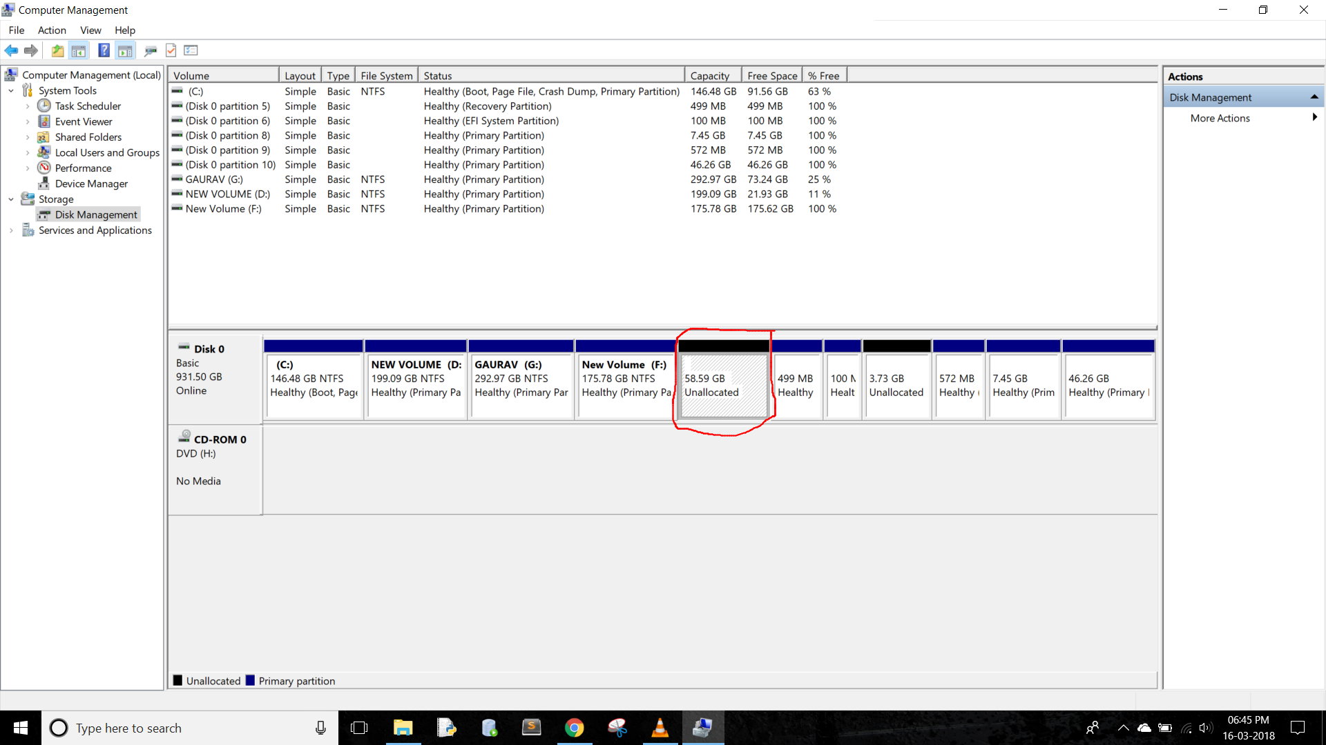

-**only for MBR**

**-**firtly check you have **extended partition**(**Green Bordered**) available or not

If **extended partition(green bordered from outside**) **present**

**-**right click on extended partition and shrink volume ,then give space for ubuntu partition (**give 50 GB**)

**-**new free space volume will be created in which we are going to install ubuntu

If **extended partition(green bordered from outside**) not **present**

-then firstly we have to create extended partition

-for that if already 4 primary partition are present then transfer data from one partitions drive data to another partition drive

-then delete that empty volume/partition and unallocated space will be created. On unallocated space right click and create New Volume and **extended partition(Green Bordered)** will be created

**-Now** right click on **extended partition(Green Bordered)** and shrink volume ,then give space for ubuntu partition (**give 50 GB**)

**-**new free space volume(Green color filled not green bordered) will be created in which we are going to install ubuntu

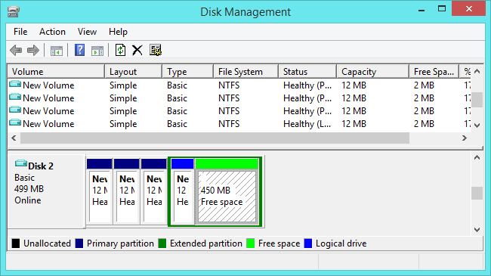

(MBR; green colour-free space to install ubuntu)

**More about disk partitioning:**

-As we know there are 2 types of partitioning schemes (GPT and MBR)

-GPT supports 128 primary partitions whereas MBR supports only 4

-GPT supports up to 9 million TB disk space whereas MBR supports only 2TB

-windows doesn’t support GPT in legacy BIOS mode.

-UEFI (Unified Extensible Firmware Interface) BIOS (Basic Input Output System) mode supports both MBR and GPT but GPT is having more advantages as stated above.

**6)Disabling fast start up:**

-right click on battery icon and go to power options

-select “choose what the power button does”

- untick the fast start and save the changes.

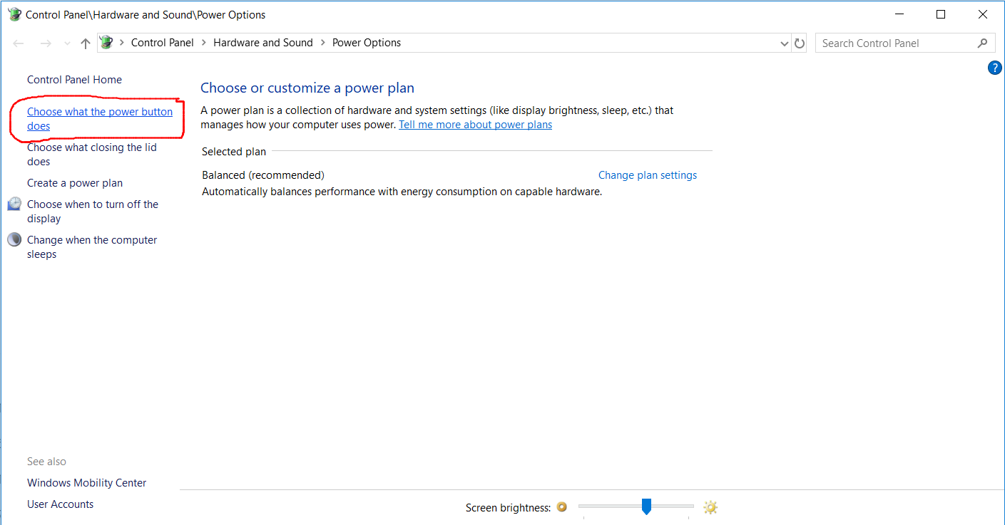

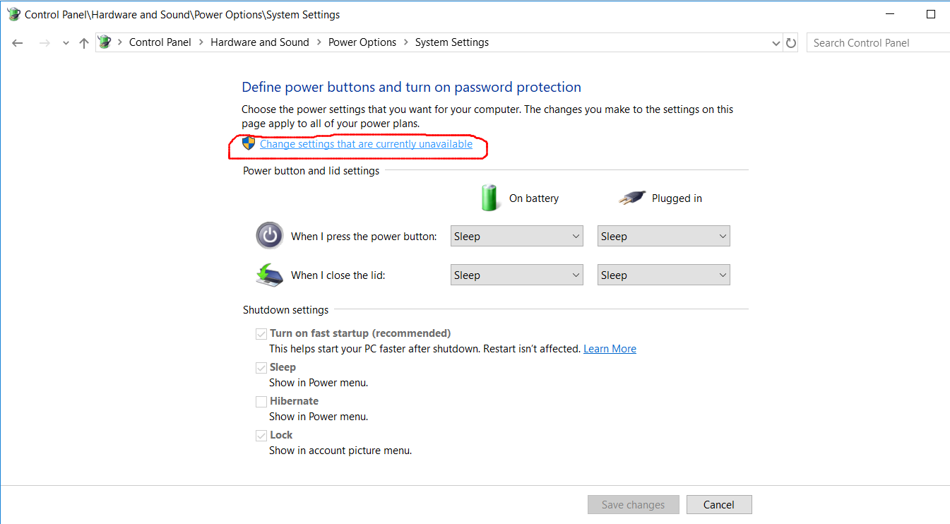

**More about Fast start up:**

-by default, windows fast start mode is ON. That is when you shut down windows it not completely get shut down

but not in sleep mode. When next time you start windows, it gets fastly started

**7) only for UEFI: Disable Secure Boot in BIOS option**

- to check **UEFI** or **legacy** open command prompt(admin) and type **msinfo32**

-see BIOS mode (note it down somewhere, will be helpful in next steps)

-if BIOS mode = UEFI then we **must disable secure boot** in BIOS settings

-for that restart your PC, immediately press your laptops BIOS key (e.g. for HP: F10, DELL: F12)-then find **secure boot option** and then **disable it and** save changes and start your PC.

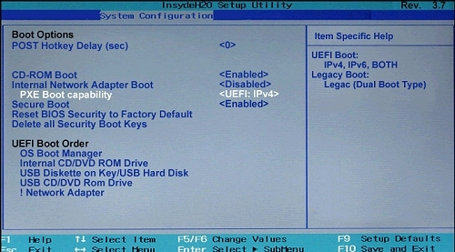

(HP laptop’s BIOS menu)

-**if BIOS mode=legacy, no need to disable secure boot** (because legacy don’t have secure boot option)

**8) Actual Ubuntu installation:**

-power off your computer

-connect bootable pen drive

-and press power button to start PC

-after pressing power button immediately press your PC’s **Boot Key** (e.g. HP: F9 key) and keep pressed until boot menu not comes.

-then if your PC is **UEFI** then select **USB pen drive [generally your pen drive name] with UEFI** if not (i.e. Legacy) select **USB pen drive without UEFI** and press ENTER

-installation process will start

-then GRUB (GRand Unified Bootloader) window will come where you can try ubuntu without installing or install ubuntu

-select install Ubuntu

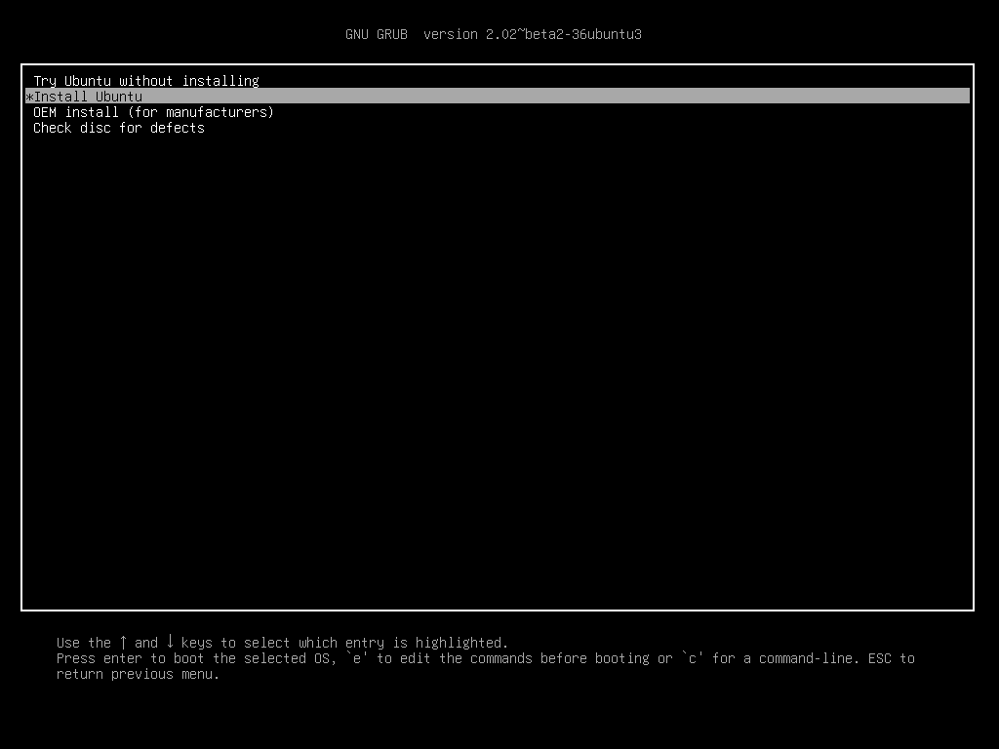

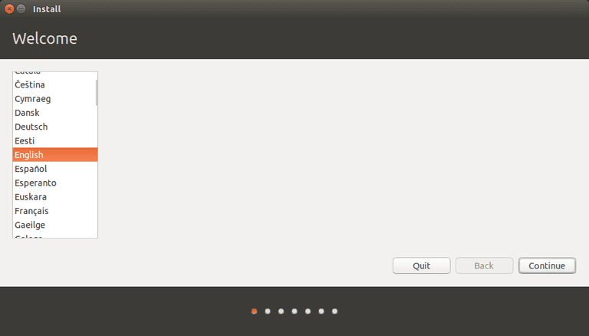-then do as done in following images

-here select Normal Installation

-untick other option i.e Download updates and Install third party softwares because it requires internet connection to install

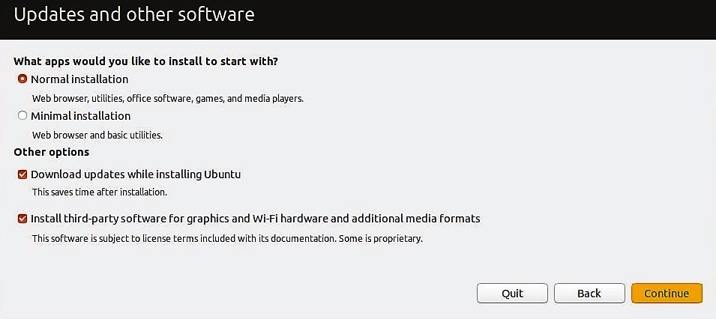

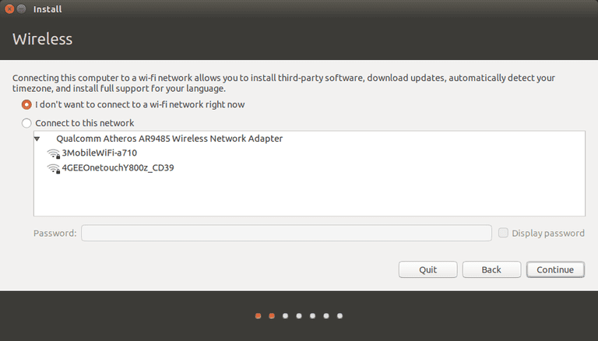

-**here select something else and install now (don’t select other options; if so might loose your data)**

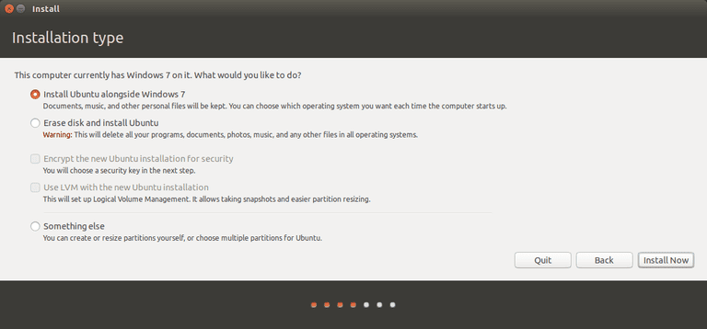

- now we have create 3 partitions (swap, boot, root) from free space partition that we have created in earlier steps

**Very important steps:**

-**select free space (don’t select other partitions like ntfs ; if so may loose your data)**

**- click on + you will get like this**

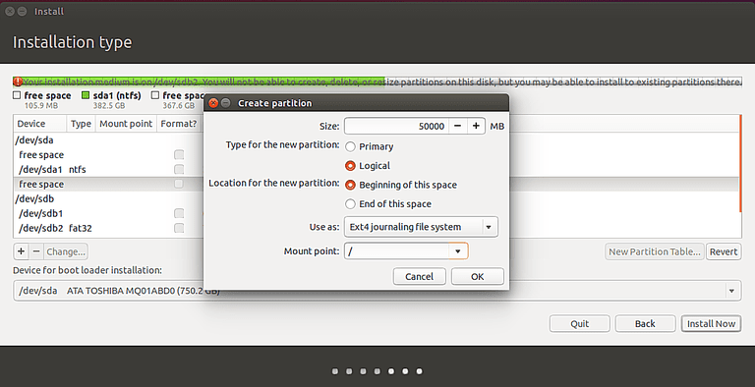

-give size=**4000mb** (or equal to your RAM in mb) (to create swap partition)

-Type of new partition=**logical**

**-**Use as **Swap area (**used as virtual RAM in Linux**) and click OK** and partition will be create with name **Linux Swap**

**-**then again select **free space (don’t select other partitions like ntfs ; if so may loose your data)**

-click on + and again

-size =500mb (or give more up to 1000 mb if enough free space)

-Type of new partition=**logical**

**-**Use as Ext4 journaling file system (by default, no need to select)

-mount point= **/boot**

**-**press OK

**-**then again select **free space (don’t select other partitions like ntfs ; if so may loose your data)**

-click on + and again

-size =remaining space i.e. no need to edit keep as it is.

-Type of new partition=**logical**

**-**Use as Ext4 journaling file system (by default, no need to select)

-mount point= **/**

**-**press OK

**--Finally select / partition and click on install**

**-then check the partitions that are going to format to install ubuntu(there should not be other partitions like ntfs)**

**-only ext4,ext4,swap should be there if not Go back and change the partitons**

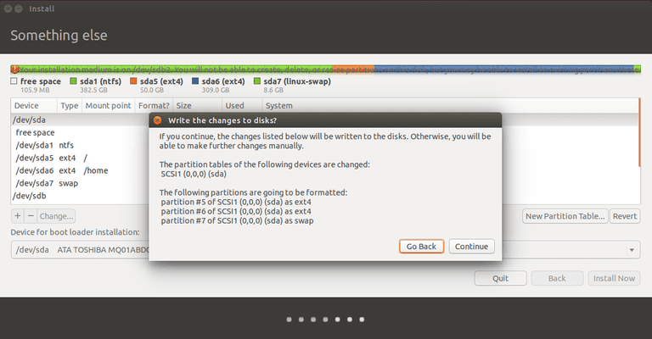

-if all set then continue and do simple steps like selection of country, keyboard language, time zone, login details

- and finally installation will be completed

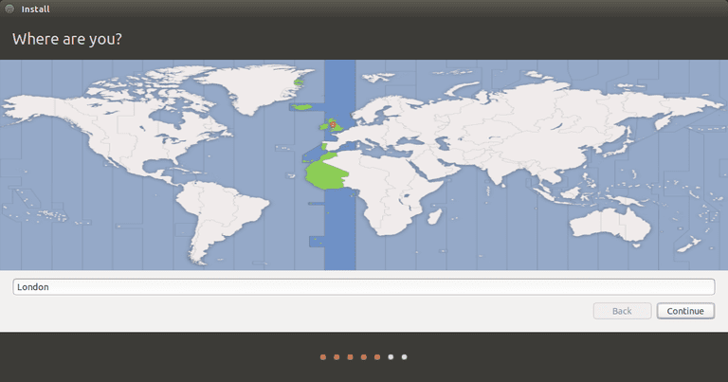

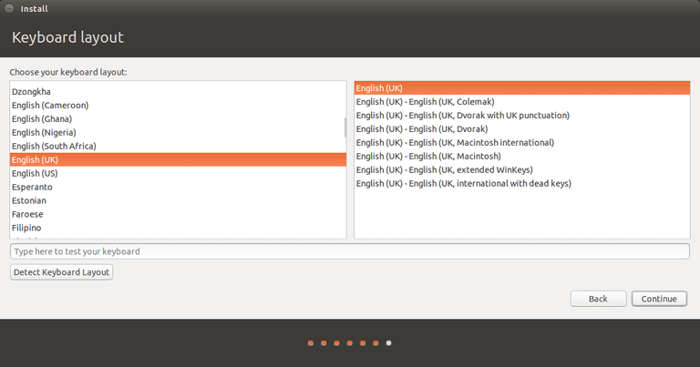

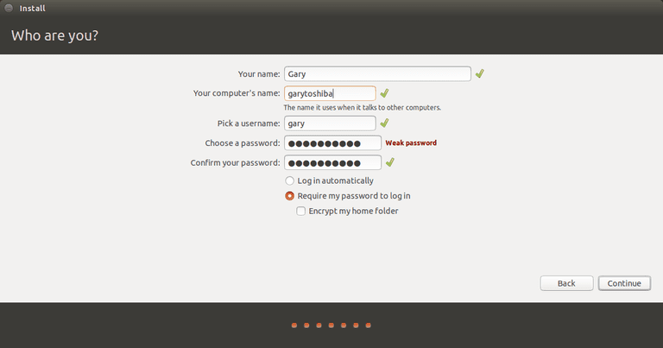

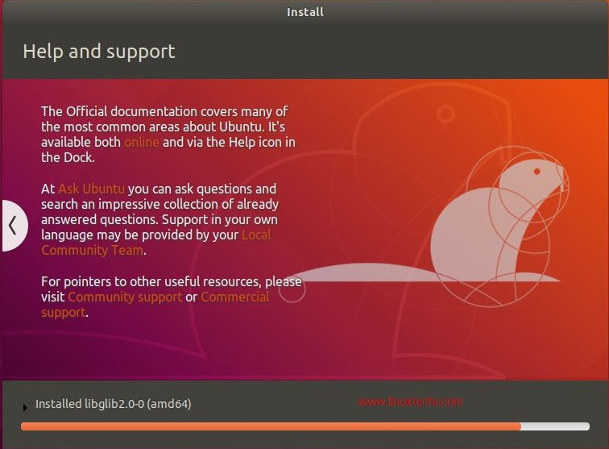

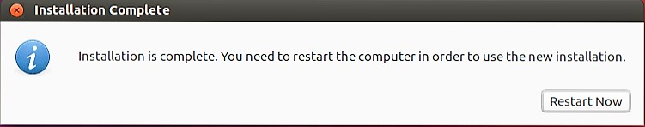

- close this window and shutdown the computer and remove pendrive or

-then select restart now or and after restart remove installation media i.e. pendrive

here **GRUB** (**GR**and **U**nified **B**ootloader) will be displayed from you can select OS (ubuntu or window)

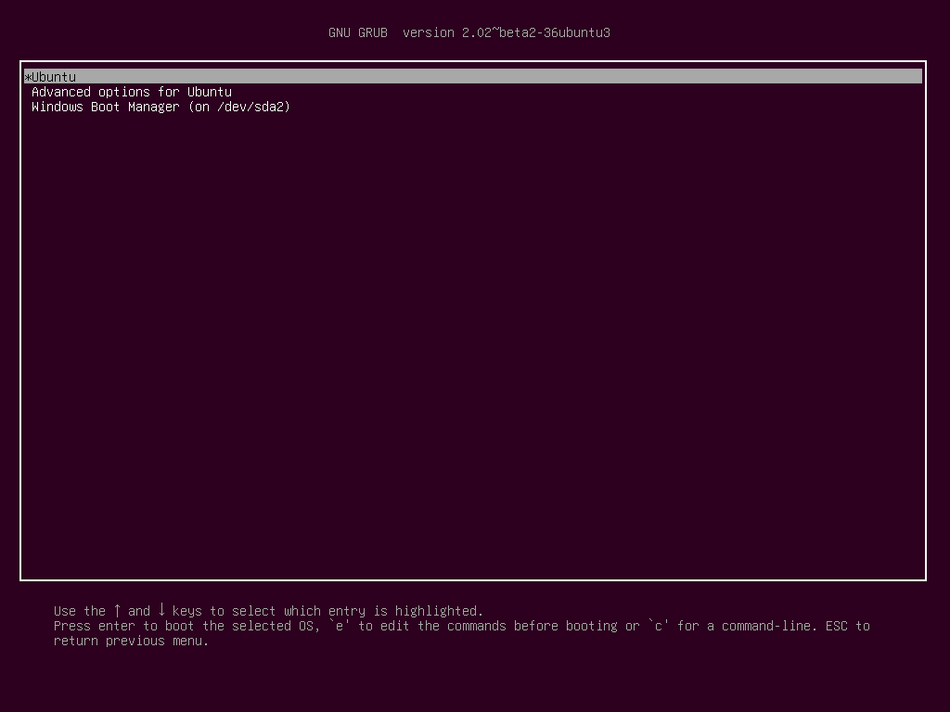

**-If GRUB is not displayed during starting of PC, automatically windows will be started**

**-so if GRUB not there:**

**-**restart your computer,while restarting press BIOS key(HP:F10) of your computer an goto Boot options -> OS boot manager

-then change priority of Ubuntu boot manager above that of windows boot manager and save changes

-GRUB will come

-if not appeared try following steps:

**-**againg restart PC press Boot key of your laptop(HP : F9 key) and select Ubuntu and ubuntu will be launched

**- to repair GRUB:**open terminal (ctrl+Alt+T) and type commands:

sudo update-grub

OR

sudo apt-add-repository ppa:yannubuntu/boot-repair  
 sudo apt-get update

sudo apt-get install -y boot-repair && boot-repair

-launch boot repair from search bar or type boot-repair in terminal and then you can repair bootloader

-and your problem might get solved

-**This is all about installation of ubuntu 18.04 LTS**

**-for more info visit: (**[https://tutorials.ubuntu.com/tutorial/tutorial-install-ubuntu-desktop#0](https://tutorials.ubuntu.com/tutorial/tutorial-install-ubuntu-desktop" \l "0))

**Install updates:**

**-**start terminal using ctrl+alt+t

-sudo apt-get update

-sudo apt-get upgrade

**Install Important softwares:**

**-**sudo apt-get install gnome-tweaks

-sudo apt-get install gcc

-sudo apt-get install g++

-sudo apt-get install vlc

**Post installation problems:**

**1.wifi problem:**

Many users will face wifi connectivity problem like low wifi signal after ubuntu installation (generally HP laptops)

solution:

-connect your computer to internet either by ethernet or by USB tethering

-open terminal(ctrl+alt+t)

-run the following commands:

1.sudo add-apt-repository ppa:hanipouspilot/rtlwifi

2.sudo apt-get update

3.sudo apt-get install rtlwifi-new-dkms

-then restart your computer

-then check wifi connectivity

-most probabally,problem might get solved.

**2.Windows time change problem:**

-due to ubuntu installation,every time when you start your windows OS ,time will be changed.

**Solution:**

-for that we have to add new entry in registry for time

-for that create new file as WindowsTimeFixUTC.reg

-and paste the following contents in that file

**Windows Registry Editor Version 5.00**

**[HKEY_LOCAL_MACHINE\SYSTEM\CurrentControlSet\Control\TimeZoneInformation]**

**"RealTimeIsUniversal"=dword:00000001**

-save the file and double click on it to run

-after that open command prompt(admin) and run the following command:

**sc config w32time start= disabled**

-time problem will be solved.

**3.Unable to access Hard disk partitions in ubuntu:**

-generally when your windows is not completely shut down that time this problem occurs

or also when you **don’t disable fast startup** in windows(already covered in installation steps)

-for that open terminal(ctrl+alt+t) and run following command

**sudo ntfsfix /dev/**your-disk-Partition-name-which is unable to access(e.g. named as sda<no>)

-your problem will be solved

**--these are the some common problems faced by users after ubuntu installtion**